 | 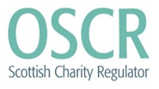 | 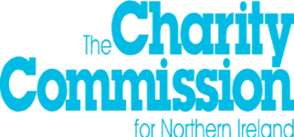 | 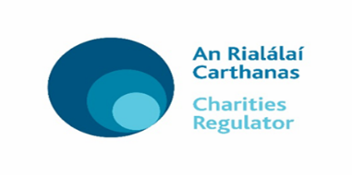

Charity Commission, PO Box 211
Bootle, L20 7YX

Enquiries: 0300 065 2002
Email: nigel.davies@charitycommission.gov.uk
Website: www.charitysorp.org

Date: 1 November 2019
Becoming an engagement partner in writing our next SORP
Dear Potential Engagement Partner
We are introducing an exciting new engagement opportunity for individuals and organisations who share our passion for high quality financial reporting and accounting by charities to assist us (the SORP-making body), and the Charities SORP Committee, in writing the next Statement of Recommended Practice (the SORP) by becoming an engagement partner. We are looking to recruit engagement partners (individual or corporate) who will be a member of one of eight engagement strands which draw together similar stakeholders.

The SORP sets out the required content of trustees’ annual reports and accounts for those charities preparing accounts that are to give a ‘true and fair’ view in accordance with UK-Irish Generally Accepted Accounting Practice. In practice this means almost all larger charities, income over £250,000 or €250,000 and also many smaller ones (for instance all charitable companies) use the SORP. By influencing the content of the SORP you influence the financial reporting for over 90% of the funds held by the charity sector in the UK and Ireland.

The attached information pack should provide you with all the information you need to decide whether to apply or not. After reading the material and satisfying yourself that you meet the eligibility criteria for your preferred engagement strand, please submit your application as requested. You should ensure your papers have been e-mailed to the named contact for your jurisdiction by 17 February 2020. An acknowledgement of your submission will be provided along with a request to complete an equal opportunities form.
Yours faithfully,

Laura Anderson Nigel Davies

Joint Chair Joint Chair

Office of the Scottish Charity Regulator Charity Commission for England and Wales

Myles McKeown Jelena Griscenko

Joint Chair Observer

Charity Commission for Northern Ireland Charities Regulator

Charities SORP Engagement Partner
Recruitment Information Pack

Contents

Background – explaining the SORP-making body and SORP Committee | 3
Writing a new SORP – why and how | 5
Choosing your engagement strand – the options | 9
Individual or organisational participation as an engagement partner | 10
The commitment required of an engagement partner | 11
Criteria for selection as an engagement partner | 12
Overview of the selection process | 13
Annex A: Payment of expenses | 15
Annex B: Provisions regarding changing membership, form and content of engagement strands | 16
Annex C: Guidance on conflict of interest | 17

OSCR, the Charity Commission for England and Wales, the Charity Commission for Northern Ireland and the Charities Regulator are equal opportunities employers and are firmly committed to ensuring, in the recruitment and development of its staff, that there are no unfair barriers resulting from gender, race, disability, age, sexual orientation, social background or any other irrelevant factor. Applications are invited from all suitably qualified individuals.
BACKGROUND - EXPLAINING THE SORP-MAKING BODY AND SORP COMMITTEE

The SORP-making body is recognised by the Financial Reporting Council (FRC); our job is to produce and publish the SORP and to ensure that the SORP is consistent with the FRC-approved accounting standards. SORP-making bodies have a responsibility to act in the public interest when developing, maintaining and issuing SORPs.

The SORP-making body currently comprises the charity regulators in the UK:
- Charity Commission for Northern Ireland (CCNI)
- Charity Commission for England and Wales (CCEW) and
- Office of the Scottish Charity Regulator (OSCR)

The FRC has agreed that the Charities Regulator, (CR) (charity regulator for the Republic of Ireland) which is currently an observer on the SORP-making body, can join as a fourth partner later if the SORP is adopted in the Republic of Ireland.

We are assisted in our work by an expert advisory Charities SORP Committee. The SORP Committee is central to the development of the next SORP. Following a SORP Governance Review in 2018-19, the SORP development process will see the SORP-making body and advisory SORP Committee working in partnership at the centre of a new engagement process. Our aim is to understand the needs of users of both the SORP and charity annual reports and accounts and consider how these can be better addressed. The SORP Committee will also help us balance the burden of reporting with the benefits it brings in order to develop a better SORP. In doing this they will be considering the feedback from you, our engagement partners.

In writing the next SORP, we are aiming to ensure that the public, funders and donors, charity beneficiaries, the media and others who read or refer to charities annual reports and accounts can obtain the information needed for decision-making about charities. We are also mindful that preparers of charity accounts who use the SORP need a SORP that delivers ‘true and fair’ accounts and enables them to tell their charity’s story well. They too need an opportunity to engage with us about what matters to them and the improvements to the SORP that they want to see.

The role of the SORP-making body is a broad one and includes the following:
- To develop and publish the Charities SORP, ensuring it is consistent and kept up to date with applicable accounting standards, law and regulations
- Decide the scope of the Charities SORP
- Have in place governance arrangements designed to lead to effective decision-making including a properly constituted Board and/or working party of the SORP-making body
- Ensure effective participation by stakeholders throughout the SORP development process, which may be formal or informal.

SORP-making bodies are expected to meet criteria laid down by the FRC and to adhere to the FRC’s policy for developing SORPs. The policy was last updated in October 2018 and requires:
- A review of the SORP at least annually – the outcome is not necessarily a new SORP but the review allows consideration of what else may need to supplement the SORP to support preparers in fulfilling appropriate requirements.
- Participation of representatives of the sector, independent outsiders on behalf of wider public interest and, where possible, users of financial statements. This will be done by working with our engagement partners and the recruitment of a new SORP Committee.
- Wide consultation on proposals, including a public consultation on any proposed changes through the publication of an exposure draft.

- For more information on the work of the SORP-making body refer to the ‘about us’ section of the dedicated SORP website: www.charitysorp.org.
- Have records retention policies for consultation responses that comply with the General Data Protection Regulations.

For more information on the work of the SORP-making body refer to the ‘about us’ section of the dedicated SORP website: www.charitysorp.org.

WRITING A NEW SORP - WHY AND HOW

Why
Since the SORP was first adopted by regulations in England and Wales it has transformed charity financial reporting and accounting. For the first time those charities that were required to or chose to prepare accounts that give a ‘true and fair’ view had a framework that they had to follow. Subsequent to the 1995 SORP, new SORPs were issued in 2000 and 2005 with the SORP adopted in Scotland in 2006. The latest SORP took effect in 2015 and was then adopted in Northern Ireland. The SORP is currently under consideration in the Republic of Ireland.

We develop the SORP to facilitate high quality reporting on the character and activities of charities and how they use the money and assets entrusted to them. This gives access to information about charities, provides transparency, supports accountability and promotes confidence in the charity sector.

In addition to the technical aspect of applying accounting standards and providing a sector-specific interpretation of accounting standards, the SORP develops requirements for narrative annual reporting. The inclusion of the Trustees’ Annual Report within the SORP’s remit ensures that narrative reporting enhances the information provided in the accounts, enabling users to better understand the aims, objectives and activities of a charity and its performance and its financial position. This joined up approach ensures a coherence to annual reporting and the involvement of the sector in developing the reporting requirements applied to it. Whilst the SORP is not a governance code, it helps to foster good practice in many areas through its reporting recommendations, for example risk management procedures and the development of reserves policies.

To be effective the SORP has to be kept up to date, not just in terms of accounting standards but also the expectations and needs of stakeholders and users. Keeping it up to date is where we now need help from our engagement partners. There are four areas where we need to keep abreast of changes:
Figure 1: Focal points for SORP development
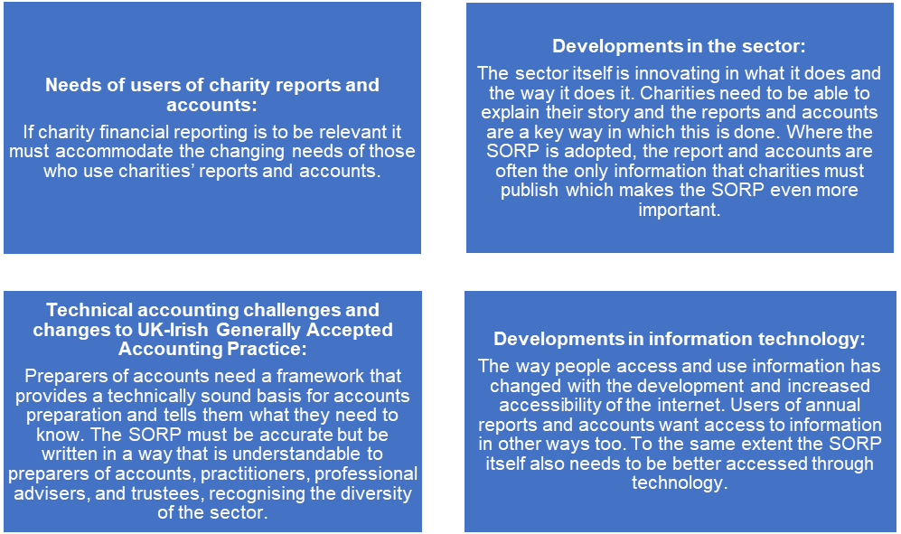
How

The 1995 and subsequent SORPs have been written with the support and advice of an expert committee. The SORP Committee helps us identify, consider and address issues relating to the application of the current SORP and develop recommendations that will assist the sector implement any new accounting standards or changes to accounting standards that have been introduced since the last review of the SORP. Once a draft SORP is written, it is put out for public comment for three months, the feedback is considered, changes made and then, provided the FRC approve it, the SORP is published and takes effect.
Following a review in 2018 of how we develop the SORP we want to invite stakeholders who read or refer to charity accounts or use the SORP to prepare accounts to be even more involved. Whilst SORP Committee members are drawn from different legal jurisdictions, parts of the sector and practise and aim to take the broad view, by having engagement partners we can broaden the discussion and gain an even better understanding of the changes we need to make. Schematically our new approach is shown in figure 2 below.

Figure 2: SORP engagement process

SORP committee
Sets the agenda for discussion and debate within Committee
Professional, audit & technical
Preparers from smaller charities & independent examiners
Considers how needs and wants from the engagement strands reconcile with current practice and UK GAAP and advises SORP-making body
SORP making body

Major funders and donors
Trustees
Academics & regulators

Larger charities
Proxies for public interest

Government & public bodies

The SORP-making body and its advisory Charities SORP Committee look to have a dialogue with our engagement partners about charity financial reporting, to identify the main things financial reporting should cover, alert us to issues or problems that need addressing and help develop the solutions to those problems. The SORP-making body and the SORP Committee will then take all pf these ideas and craft them into the next SORP. We expect that writing the next SORP will take three to four years. How the SORP will be written will involve six stages with our engagement partners involved at each stage in partnership with our expert SORP Committee. Different stakeholder groups may progress at different speeds and choose to emphasise different stages of the process.
The dialogue between SORP-making body, SORP Committee and engagement partners will involve some aspects where an agenda is set and also times of independent creative thought. We anticipate exchanges of ideas and debates about potential solutions. Ultimately there may be choices to make in writing the next SORP between different options or ideas and the SORP-making body will make those choices after taking advice from the advisory SORP Committee.
The earlier stages of writing the SORP will be the most intensive with the input from the engagement partners being less once the drafting process begins.
Figure 3: The stages of the SORP development process

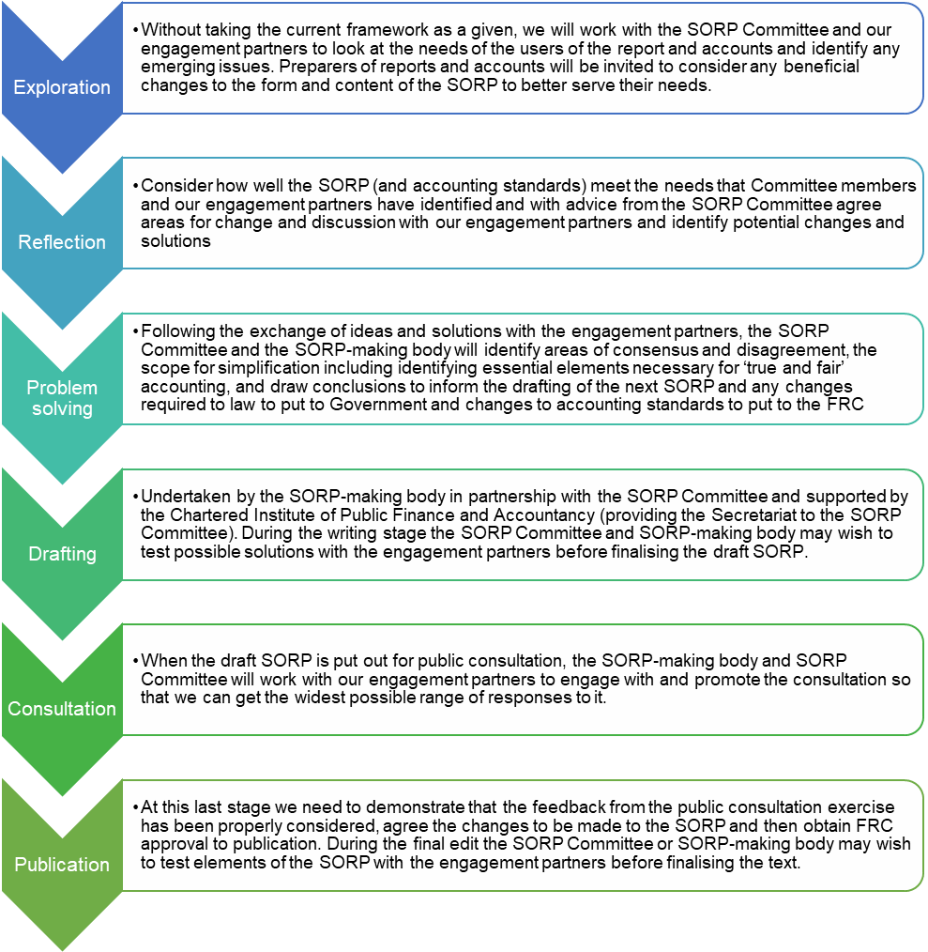
In terms of the duration for each stage, our best view is set out in the table below. This assumes the work commences in March 2020.

Stage | Approximate time | Completed by earliest timing (latest timing)
Exploration | 3 to 6 months | June 2020 (September 2020)
Reflection | 3 to 6 months | September 2020 (March 2021)
Problem solving | 3 to 6 months | December 2020 (September 2021)
Drafting* | 6 to 12 months | June 2021 (March 2022)
FRC review and public consultation* | 6 months | December 2021 (March 2023)
Final edit and FRC approval* | 3 to 6 months | March 2022 (September 2023)
Effective date* (allowing 3 month lead in) | - | Reporting for years beginning 1 August 2022 (1 December 2023)

*Drafting can only commence once the work of all the engagements strands has been completed and the findings from the engagement strands have been considered by the SORP Committee. Drafting is also contingent on any required changes to the UK-Irish accounting standards and/ or approval of government being made or agreed. The timing of subsequent stages is therefore also dependent on the completion of the draft SORP for public consultation.
CHOOSING YOUR ENGAGEMENT STRAND - THE OPTIONS
The idea is that each engagement strand draws together a similar group of stakeholders who use charity reports and accounts and / or the SORP so they can share their views and insights on the issues in charity reporting and accounting as they see them. We can then better understand the viewpoint of each stakeholder group and this will help us better appreciate their needs and areas of agreement or disagreement. Knowing this will help us make better choices about charity reporting and accounting that serve the readers of charity reports and accounts and the users of the SORP.

We plan to convene the following 8 engagement strands as shown in figure 2:

Preparers from larger charities:

To articulate the challenges facing larger charities and offer suggestions as to financial reporting issues that require a solution, ideas for simplification and insights into how the SORP can be changed to enable larger charities to better tell their story to users.

Preparers from smaller charities and independent examiners:

To articulate the challenges facing smaller charities, offer suggestions as to simplification and identify the key elements necessary for reporting their charity’s story.

Professional, audit and technical:

Since the bulk of sector resources are managed and governed by less than 1% of charities the technical challenges and reporting needs that come with scale need to be articulated and solutions suggested. Auditors, independent examiners and practitioners with experience across a number of charities will have an appreciation of technical points that need to be addressed or common reporting challenges faced by their clients.

Trustees:

Trustees are legally responsible for overseeing or undertaking the preparation of the report and accounts and so need to be able to articulate their charity’s story, account for their stewardship of funds and be able to understand the final report and accounts.

Government and public bodies:

They are major funders accountable for public money and therefore need insight into the benefit charities provide and their use of resources and public money and service continuity and quality.

Major funders and major donors and providers of loan funding:

Require insight into the benefit charities provide and their use of resources and financial resilience.

Proxies for the public interest, beneficiaries, volunteers and smaller donors:

On behalf of stakeholders that support or benefit from charities, the proxies articulate what people generally expect charities to report which is considered essential to maintaining public confidence in the sector and will affect their decision-making about supporting or understanding the work of charities.

Academic and regulators:

Academics have a clear view of the theory of accountability and regulators have a particular role in contributing to public interest and confidence in charities whether it is in charities’ service delivery, fundraising, conduct or lawful use of resources.

You can only be a member of one strand and so it is best to opt for the strand that best represents you, your organisation or your members.

INDIVIDUAL OR ORGANISATIONAL PARTICIPATION AS ENGAGEMENT PARTNER
You can apply to join an engagement strand either as an individual or request organisational membership. The criteria for participation differ between the types of membership.

Individual membership is intended for people who have a good appreciation of the sector and its challenges either because of their participation as commentator, through academic study, donor, funder, trustee or employee or adviser, or practitioner engagement with charities. We will look to individuals to share their insights and views gained from personal experience of the sector. Individual membership is not transferrable.

Organisational membership is intended for organisations that:

- fund the sector
- engage with the sector
- represent the sector or
- are professional accountancy bodies.

Organisational members will identify a named individual to represent their organisation and may by prior agreement, change their nominee. Organisational members will be reflecting the view of their organisation.
THE COMMITMENT REQUIRED OF A SORP ENGAGEMENT PARTNER

We intend the new SORP engagement process to be flexible and creative and so at the outset we are not setting out a strict format that each engagement strand must follow. Therefore at the outset there is a degree of uncertainty as to how much time and effort is being sought. Instead at the initial meeting of each strand, the participants will agree amongst themselves the approach they would like to take to the process and how much time and effort will be asked of participants. We anticipate that this initial discussion will draw out the likely frequency for dialogue or meetings and clarify the likely commitment of time. It will also identify what resources or facilities might be needed so that organisational members can identify how far they can contribute to meet these needs. Each engagement strand will be asked to identify who will lead or chair the discussion from amongst its members (referred from here on as ‘the convenor’).

Subject to available resources, the Secretariat support for each engagement strand will be provided by staff drawn from the SORP-making body. Their role will be to facilitate and record the dialogue and provide technical accountancy expertise to support each engagement strand’s consideration of the issues.

The main tasks and activities we anticipate for each engagement strand are to:
- appoint a convenor to chair the meeting and settle the agenda for discussion, working with any Secretariat support provided by the SORP-making body
- prepare for, and attend meetings of the engagement strand.
- contribute to projects and activities as appropriate.
- help champion and promote the engagement process and what the SORP is trying to achieve.
- actively participate in the conversation in the engagement strand and support the convenor.
- (if an organisational member) provide access to your membership and promote engagement through articles, surveys, focus groups, questionnaires, meetings, social media, webinars and other means as appropriate.

As a member of an engagement strand, you would be expected to be a team player who will honour and respect the input of others and contribute to a full and exhaustive debate of the points at issue and constructively engage to determine the consensus view, which may not necessarily concur with their own. A volunteer convenor would not normally hold that role for more than two years but can be extended to up to four years by agreement with the participants in the engagement strand.

You will have the capacity to form and maintain excellent working relationships with fellow engagement strand participants and the sector at large with personal qualities which command confidence with charities, stakeholders and the media.

To participate you need to have read and confirmed that you understand the privacy statement and agree for your contact details to be retained by the SORP-making body and shared with other participants within your engagement strand.

The appointment to an engagement strand is for a fixed term of four years, with the possibility of extension by mutual agreement.

Whilst attendance at every meeting of an engagement strand is not mandatory, a member is expected to use their best endeavours to attend the initial meeting and subsequent meetings and only miss a meeting due to exceptional circumstances.

CRITERIA FOR SELECTION AS AN ENGAGEMENT PARTNER
It is expected that applicants, will have obtained the permission of their employer to participate in the engagement strand prior to submitting their application. The applicant and their employer are advised to consider carefully the time commitment that is likely to be involved and ensure that they would, if successful, be able to remain involved for the full term of up to four years to December 2023.
Criteria for selecting an individual member involves the individual demonstrating a history of involvement or engagement with the charity sector. Credit will be given for:

- Experience of contributing to the governance, reporting or accounting arrangements for an organisation. Evidence includes published articles and blogs, research, trustee positions, professional or voluntary engagements, and presentations at charity events.
- Willingness to work with others and respect different views. Evidence includes tasks or initiatives involving leading or working in teams.
- Experience of acting as a spokesperson/ambassador for an organisation in its communications with external and internal stakeholders. Evidence includes published articles and blogs, research, presentations at charity events, participation in forums, panels, workshops or sector committees.
- Good communication and influencing skills. Evidence includes published articles and blogs, research, presentations at charity events, participation in forums, panels, workshops or committees.

Criteria for selecting an organisation as an engagement partner involves a focus on the relationship the organisation has with the sector and its willingness to support the process by committing staff time, facilitates and resources to support the engagement process. Having made a reasonable allowance for an organisation’s size, resources and character, credit will be given for:

- Engagement with the sector - its nature, consistency, depth and duration. Evidence will be provided by the organisation’s purposes, an explanation of its engagement including any policies or agreements involving the charity sector that are in the public domain, and collaborative working or involvement in the sector with respect to financial governance, good reporting, accountability and transparency.
- Willingness to commit time - members of each engagement strand will decide early on how often to meet, the form of interaction (email, phone, conference call, internet forum or physical meetings) and how they will work together but in joining up a member agrees to participate as much as possible which is quite likely to involve work between meetings.
- Willingness to commit facilities - whether a room to meet, a conference call facility, secretarial or administrative support to the engagement strand.
- Willingness to commit resources - whether through polling its members, articles, webinars, events, focus groups, polling its committees or charity panels, contacting its networks or use of social media to draw in views.

Skills and attributes asked of both individual and organisational partners

- Ability to think and act strategically using creative, analytical and problem-solving skills.
- Ability to translate ideas into practical solutions.
- Familiarity with and either a good understanding of accounting standards and the latest SORP or an awareness of the latest SORP and what it is trying to achieve, and a recognition of what good financial reporting is trying to achieve.
- Commitment to valuing diversity and respecting others.

OVERVIEW OF THE SELECTION PROCESS
Applications are invited by open advertisement. Unsolicited approaches may be made to certain individuals who have either served on the previous SORP committee or are considered to have a valuable input to give due to their prominent engagement with the charity sector or organisations, at the absolute discretion of the SORP-making body for them to apply. All applications will be reviewed against the selection criteria and will receive equal treatment in respect of gender, ethnic origin or personal disability.

The SORP-making body will determine whether to run an engagement strand separately in each of the four charity law jurisdictions (England and Wales, Northern Ireland, Republic of Ireland and Scotland) or to combine two or more jurisdictions. Factors informing this decision include cross boundary or cross border synergies, our available resources, and the levels of interest shown in participating in the process. For each engagement strand we are looking for between 12 and 16 participants.

Each of the four participating charity regulators will identify its selection for its charity law jurisdiction. These selections will be considered at a meeting of the joint SORP-making body and then the successful applicants will be notified. A reserve list will also be maintained of up to four participants per engagement strand in order to fill any vacancies should these arise. Those placed on the reserve list will also be notified and their consent requested for inclusion on the reserves list. The reserve list would be kept for a period of three years.

To apply to join an engagement strand, you need to provide the following information by 17 February 2020:

- If applying as an individual:
  - your CV setting out your career history, with responsibilities and achievements and/or history of engagement with the sector.

- If applying as an organisational member:
  - a short statement setting out how the work of your organisation relates to the charity sector including details of your organisation’s website and social media presence and details of your proposed nominee, for example whether the person nominated is a member of staff or a volunteer member

- In all cases:
  - a brief supporting statement (this should be from the nominee of an organisational applicant), giving evidence and examples of your ability to meet the criteria for selection The statement should not be more than 2 sides of A4.
  - confirmation you have read the SORP-specific privacy statement found on www.charitysorp.org and are happy to participate on this basis.
  - confirmation that if appointed you are content that your email address will be shared with other participants in the engagement strand and be known by the SORP-making body
  - daytime and evening mobile telephone numbers, which will be used with discretion.
  - e-mail address, which will be used with discretion.
  - a statement of any conflicts of interest. If you, your partner, dependants, business partner or associate have any business interest or other activities which are or could be perceived as creating a conflict of interest with the activities of the SORP Committee or the SORP-making body, you should declare that in your application. If you have no conflicts of interest to declare, a simple statement in a covering letter to this effect will be sufficient. Please read the attached note for guidance in Annex C on this matter.

In addition, all applicants are requested to complete:

- Ethnic minority and disability questionnaires which enable us to comply with the recommendations of the Equality and Human Rights Commission, to monitor selection decisions. This information will be treated as confidential and used for statistical purposes only; the forms will not be treated as part of your application.

Completed applications should be sent by email to the contact person nominated for your jurisdiction, quoting reference SORP ENGAGE, to:
For England and Wales: | Nigel Davies | Nigel.Davies@charitycommission.gov.uk
For Northern Ireland: | Myles McKeown | Myles.McKeown@charitycommissionni.org.uk
For the Republic of Ireland: | Jelena Griscenko | JXGriscenko@charitiesregulator.ie
For Scotland: | Laura Anderson | laura.anderson@oscr.org.uk

Equal opportunities
The SORP-making body is committed to a policy of equal opportunity for all staff and these principles will apply equally to appointments made to the SORP engagement panels and the Charities SORP Committee. We will not discriminate on grounds of gender, ethnic origin, disability, sexual orientation, faith or any other factor irrelevant to a person's work.

Pre application queries

If after reading the material you have further questions about any aspect of this appointment, or wish to have an informal and confidential discussion about the position you can call the nominated contact person for your jurisdiction.

ANNEX a: PAYMENT OF EXPENSES

Travel related expenses will be not be paid to any member of an engagement strand for attending meetings convened by the engagement strand. Other expenses, such as room hire, lunch or refreshments will only be reimbursed with prior approval of the SORP-making body.

ANNEX B: PROVISIONS REGARDING CHANGING MEMBERSHIP, FORM AND CONTENT OF ENGAGEMENT STRANDS

Change in engagement participation

We welcome the involvement of volunteers who share our passion for high quality financial reporting by charities and a desire to see a SORP that meets the needs of those putting the report and accounts together. We do though need to ensure that the way members work together is good and aligned with the way the SORP can be developed.

In terms of working together, we need members to demonstrate a sufficient level of support, input and interest in the work of the SORP-making body and the engagement process including promoting the work of the SORP Committee. To facilitate effective engagement work, should the conduct of a member persistently fall below that which could be reasonably expected, then the SORP-making body are empowered to contact the member and discuss the situation and, if a way forward cannot be agreed, at their absolute discretion, to formally write to the member advising them that their membership has ceased. Similarly, if the conduct of a organisational member falls short of what is expected and a way forward cannot be agreed then the SORP-making body at their absolute discretion, will formally write to the organisation advising them that their organisational membership has ceased

The Chairs may also, at their absolute discretion, publicise the cessation of membership and changes to engagement strand participation on the dedicated charity SORPs micro-site: www.charitysorp.org.

Change in the form of the engagement strand

The engagement strands are a new innovation in the SORP process and in the light of future experience the SORP-making body, in discussion with engagement partners affected, may change the format of an engagement strand by merging one strand with another or demerging a strand or combining two or more jurisdictions within a strand.

Change in the content of the engagement strand

The SORP considers the form and content of reports and accounts and so the SORP Committee or SORP-making body may specifically task engagements strands with considering certain issues or matters in addition to considering the feedback from engagement strands. In order to facilitate progressing the SORP in a timely way, the SORP-making body may need at times to direct the work or activities of an engagement strand. Such direction will be made after an initial discussion with the engagement strand(s) affected.

Confidentiality

Involvement with an engagement strand is no bar to an individual or organisation holding position on a matter, speaking out on a matter or advocating a position on a matter. Participation is subject to confidentiality being respected with respect to any papers that are circulated, discussions held, or matters being identified for future discussion. Nothing that the engagement partner comes across may be referred to publicly unless it has either been put in the public domain or the convenor of the engagement strand or the joint chair(s) of the SORP Committee have given approval.

ANNEX C: GUIDANCE ON CONFLICT OF INTEREST

SORP engagement partners are not employees of the SORP-making body and are therefore not contractually subject to the general rules binding civil servants, in particular those set out in the Civil Service Code and other relevant documents, covering such matters as confidentiality and disclosure of official information, standards and propriety, acceptance of outside appointments and publications. However, it is expected that SORP engagement partners will voluntarily undertake to apply certain general principles whilst serving on a SORP engagement strand.

For example, publications made on a personal basis, not committing the SORP-making body or SORP Committee, do not have to represent the policy position of the Commission, OSCR or the SORP Committee, however, and they should not conflict with or discredit the work of the SORP Committee or SORP development process. Any article or published statement relating to the work of the SORP engagement strands, the SORP Committee, SORP-making body should, as a matter of courtesy, be copied to the SORP-making body in advance of publication.

A current involvement in the charitable sector will not be seen as creating a potential conflict of interest in terms of membership of a SORP engagement strand. Employment with a charity or trusteeship should however be disclosed as part of your application.

Similarly audit appointments, advisory roles and consultancy work within the sector, provided they are declared, are compatible with appointment to a SORP engagement strand. A general statement that you are involved in such work will generally be sufficient and a client listing will not be required.

Conflicts of interest may however arise where as part of your employment or other contractual arrangements you are mandated to particular policy position in relation to an accounting issue or standard that conflicts with existing or developing SORP recommendations. Where such a situation may impede SORP deliberations, for example, the arrangement is such that it creates an expectation that you will lobbying for a particular accounting treatment or disclosure requirement, then this position should be disclosed to the SORP-making body prior to any deliberations by the SORP engagement strand on this issue in question.

